
Implementing JWT Web API security in .NET 9

Source code here

In this article we are going to explain
how to provide authentication and
authorisation capabilities in .NET 9 Core
based Web API that supplies access to
various functionalities of a real-life
application, protecting it by implementing
JWT authentication and storing user
credentials in a MongoDb database.

This is a straight-forward procedure
easy to implement and offers a
nice layer of security that complies
with industry standards for web
development.

Author of the article: Iker Elg. Alzaa
#Cybersecurity #NET #JWT #WebAPI
#Identity #Mongo


Authentication is the process of validating user credentials and authorisation is the process of checking privileges for a user to access specific modules in an application.
For this purpose, we protect a .NET Web API application by implementing JWT authentication in both sides, the front and back-end. This article covers the back-end side, being available the front-end the next articles that will be released.
JSON Web Token (JWT)
JSON Web Token (JWT) is an open standard (RFC 7519) that defines a compact and self-contained way for securely transmitting information between parties as a JSON object.
JSON Web Tokens consist of three parts separated by dots, which are:
- Header
- Payload
- Signature
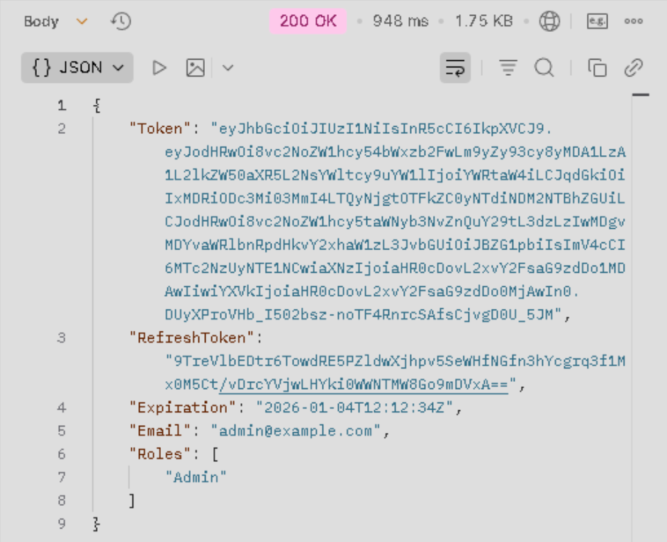
Therefore, a JWT looks like the following:
This information can be verified and trusted because it is digitally signed using a secret (with the HMAC algorithm) or a public/private key pair using RSA or ECDSA.
To implement the JWT authentication procedure we need to install the next Nuget packages.
- AspNetCore.Identity.MongoDbCore, this is a MongoDb UserStore and RoleStore adapter for Microsoft.Extension.Identity.Core
- Microsoft.AspNetCore.Authentication.JwtBearer, this package enables the application to receive an OpenID Connect bearer token
Auth. model implementation
After loading the Nugget packages, we start our implementation creating a new folder called Auth where to store all the models to manage the authentication and authorisation process. This is the place where we are going to define our Identity “User” and “Role” classes.
The Identity Role class inherits from MongoIdentityRole class and is mapped to Roles collections, the analogous happens with the Identity User. We also create a static class UserRoles to add two constant values Admin and “User” as roles.
Then create a User.cs class for new user registration. In this class we store the personal information for each user (Name, Email and Password). We store the login user credentials (name and password) inside the LoginModel.cs class.
To store the information required by the JWT authorisation we create the TokenModel.cs class. In this class we store the AccessToken and the RefreshToken. The access token is valid for the time period we stablish in the appsettings.json file. After that period of time, we have to create a new token with the refresh token.
To manage the http requests responses, we create the Response.cs class. In this class we define the response message and the response status code.
Configuration (appsettings.json)
After creating all the authentication and authorisation models classes, we proceed with the appsettings.json file modifications.
We have to include a new section “JWT” inside the file and we define five new variable (ValidAudience, ValidIssuer, Secret, TokenValidityInMinutes and RefreshTokenValidityInDays) like this:
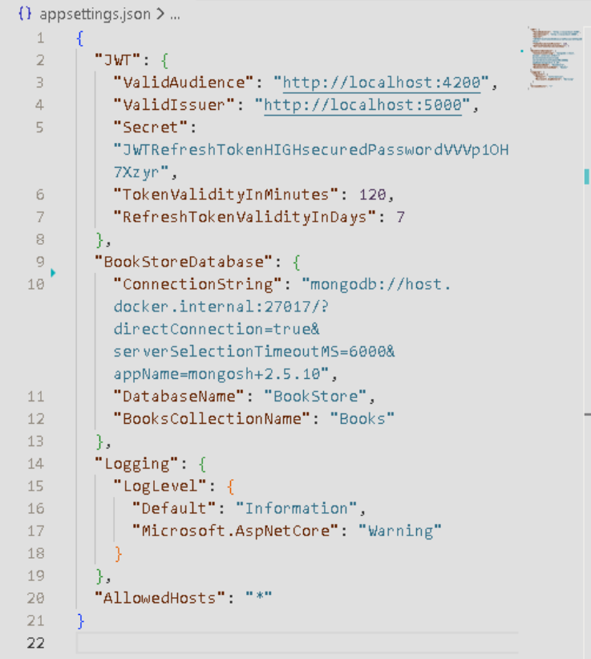
- ValidAudience: What is the target of this token. In other words, which services should accept this token an access token for the service.
- ValidIssuer: Who created the token. In this case is our localhost web API. When we launch the API.
- Secret: The secret will be used for setting the JWT IssuerSigningKey. It is the public key used for validating incoming JWT tokens.
- TokenValidityInMinutes: the access token is valid for the period of time established in this variable. After that time the token expires and the user should request a new token with the aid of the refresh token.
- RefreshTokenValidityInDays: as an additionally functionality we can set the refresh token expiration time.
We define the MongoDb, the Identity database, as the database for storing the user’s credential (usernames, roles, etc). The MongoDb must be running in three Docker containers our localhost in port 27017, 27018 and 27019.
We also configure the JWT Authentication system in Program.cs.
API controller
After introducing the required modification in the middleware, we are going to create an API controller AuthenticateController.cs inside the Controllers.
- RegisterUser, RegisterAdmin: this function receives as a parameter the new user info (username, password and email).
- Login: after registering a new user, we have stored the user personal information in the MongoDB with the token.
- Revoke: in case we would like to revoke the permissions granted to a user, we can set to “null” the RefreshToken, then the user cannot login again.
After the Authentication process (register user, login, create token, etc.) defined in the AuthenticateController.cs, we have to authorise users to access the actions in the BooksController.cs.
For this purpose, we include the [Authorize] attribute in all the actions where we require a granted permission to be accessed, together with with the permitted role if needed.

